Thinking about audience

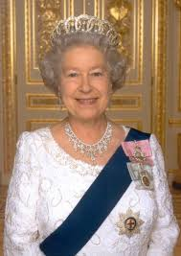
When you create a text (a piece of writing) you must take into consideration your audience. You would write using different words, tone and content depending on who you wrote to.
1. Write two small letters, one inviting the Queen over to your house, and the other inviting Kayne West over. If you don’t know who these people are you can ask someone or look them up on the internet.
2. Write a small paragraph explaining how the two letters were different and why.

Kayne West
The Queen of England

