Ancient China

Dynasties
What is a dynasty?
A dynasty is when one family rules a country or region over a long period of time. Generally, the head of the family will be the ruler of the land, like an emperor or king. When that ruler dies, another member of the family will take power, usually the oldest son. When a new family takes control, then a new dynasty begins.
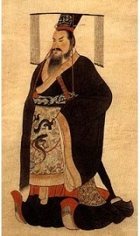
The first Emperor of China - Qin Shi Huangdi

