Creating a Dichotomous Key for Alien Creatures
Remember:
- Use something really easy for your first step.
- Finish classifying one organism before moving onto the next one.
- Put a picture of each alien once you have classified them. The pictures are at the bottom of this page.
- Below is an example to get you started.

Your Dichotomous Key

Step 1a: Alien has one eye… it is Alien H 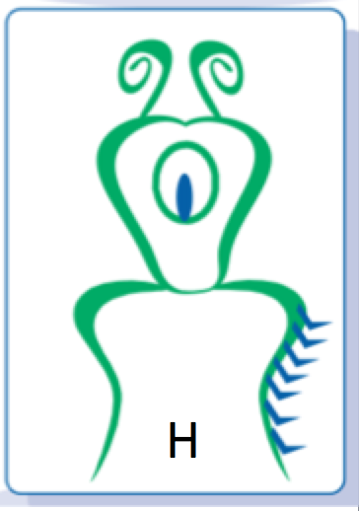
Step 1b: Alien has more than one eye… go to Step 2.

Step 2a:
Step 2b:

