CAT2 - Renewable Resources

Introduction
Torquay is rapidly expanding, which means there is a greater strain on the communities resources. As populations increase, we need to become smarter in how we use the resources we have, and protect them for the future.

Renewable vs. Non-renewable Resource Flowchart
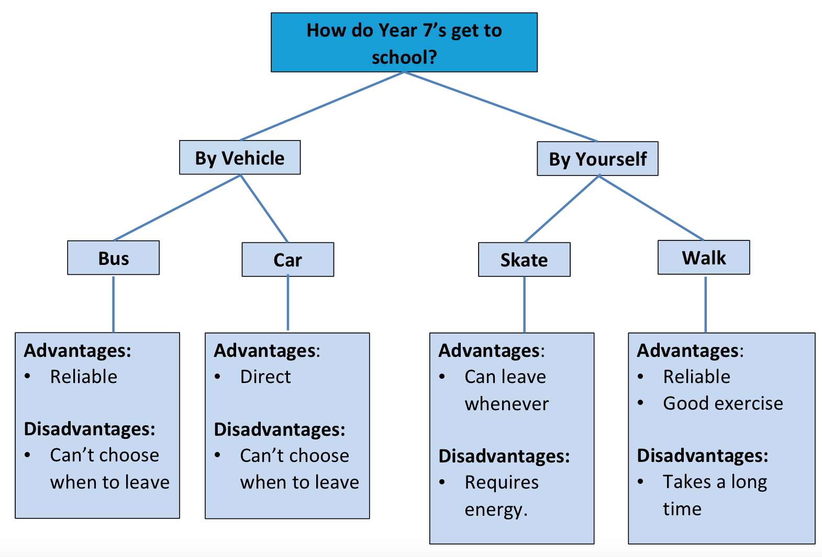

The issue with non-renewable resources:
Currently we are rely heavily on non-renewable resources, and in an area such as Torquay that is rapidly expanding, this could become a problem…

A suitable renewable resource for Surf Coast
I believe that the renewable resource of the sun could be used in and around Surf Coast.

How I would use the renewable resource
This is how I would make use of the sun to create energy for the people of Surf Coast. In my diagram, you can see…
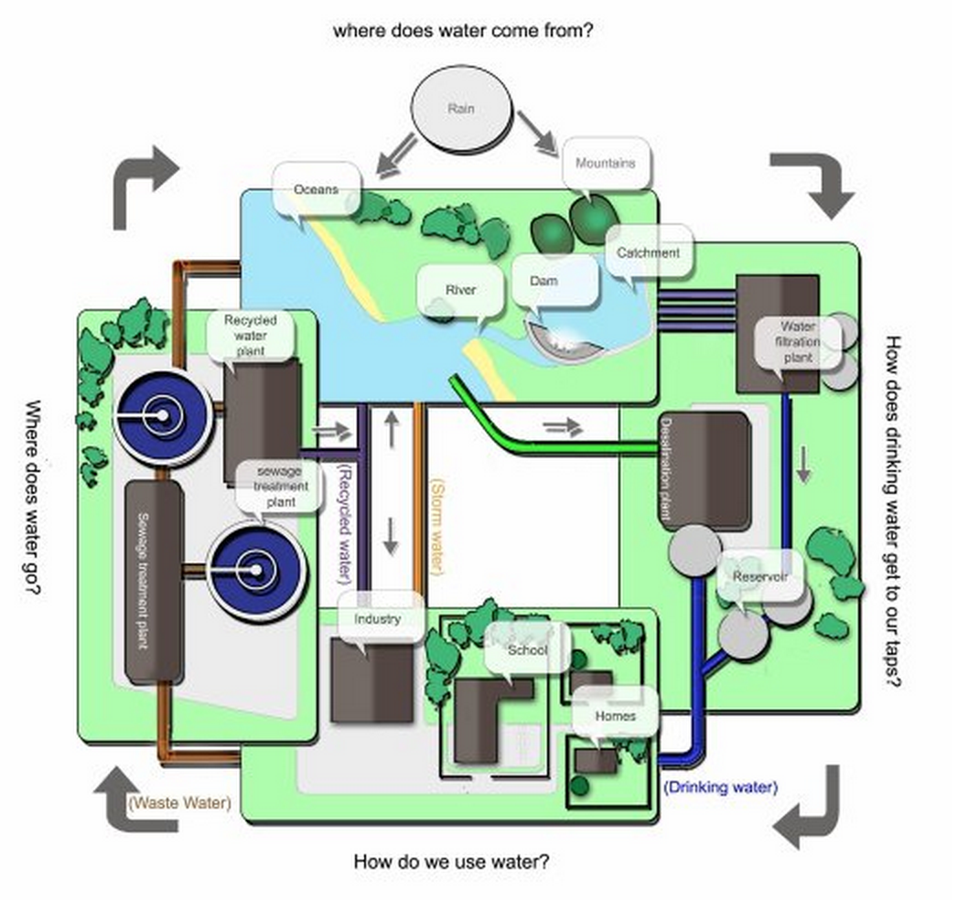

References:
Website with Author:
Author, A., & Author, B. (Publication date). Title of page. Retrieved from web address.

Website with No Author:
Title of page. (Publication date). Retrieved from web address

