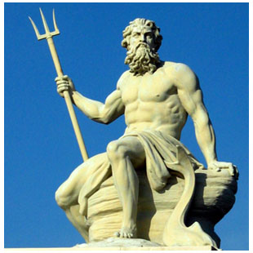

**Ancient Greek Gods**

**Task:**

Read over this website: <http://www.factmonster.com/ipka/A0881990.html>

Become familiar with each of the twelve Olympian Gods and Goddesses.

*Imagine that you’re in Mount Olympus. Zeus, the head of the Olympian Gods and Goddesses has come to you because he has realised that there are not enough Gods or Goddesses to fill the seats in Olympus.*

*Your task is to design your own Olympian God or Goddess. You must show that you have learnt details about other Gods and Goddesses in your explanation.*

Things to include:

* Name of Olympian God.
* What are they the God of? Their responsibilities?
* Their connection to Olympus. What Gods are they related to? Are they married? If so, who to?
* What is their personality like?
* What are their powers?
* Who are their friends in Olympus? Why?
* Who do they dislike in Olympus? Why?