Health and Wellbeing
- Many Chinese people came to see the world as being controlled by two equal and opposite forces: yin and yang. These had to be in balance. Their imbalance in the body, for example, was said to cause illness. Acupuncture was believed to fix this by correcting the body’s energy flows. Acupuncture was first used around 2700 BC; it is still used by many doctors today.

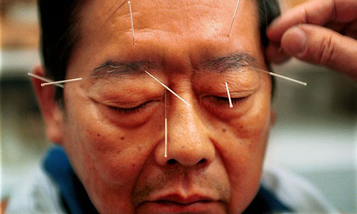

- Look at this image of someone receiving acupuncture. What does the treatment involve?
Balance and Harmony
- Belief systems played an important role in forming the values of ancient the Chinese. Order, harmony and self-control were highly regarded. These values were reflected in social practices such as the martial arts, feng shui, and rituals such as tea-drinking ceremonies. Tea was first drunk as a medicine or stimulant and since the Tang dynasty it has become more of a ritual – a ceremony where people relax and formally socialise.

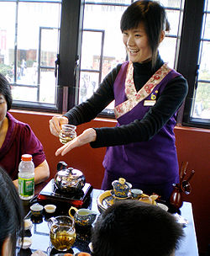

- Look at this image from a traditional Chinese tea house. What customs are evident? How is this similar to or different from a café in Australia?

Kung Fu
China is famous for the practice of martial arts, particularly kung fu. Both a mental and physical discipline, kung fu blends the self-defence skills of ancient warriors with values such as balance, self-control, harmony and respect. A kung fu master learns to use the ‘chi’, described as the energy force of the universal power.

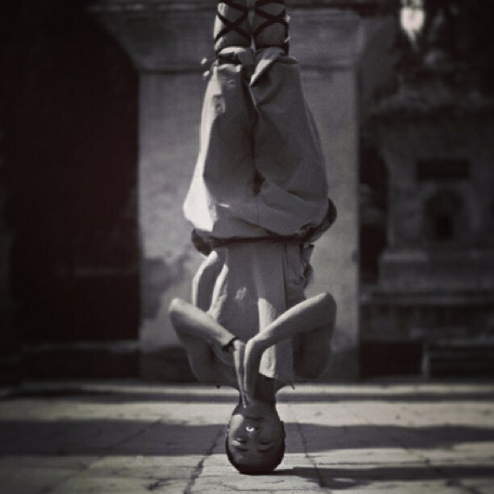

- Look at this image of a kung fu expert. What physical and mental skills would this man need to hold this pose?

Taoism
Taoism (or Daoism) began with the teaching of Lao-Tzu (600-531 BC). He believed that to live forever, people had to become one with the life force (the Tao or ‘the way’). This effore required constant change to balance within oneself the yin (female) and yang (male) forces that made up everything in the world. This spiritual struggle was helped by meditating (usually at shrines built in beautiful natural spots) and exercise (such as kung fu and tai chi).

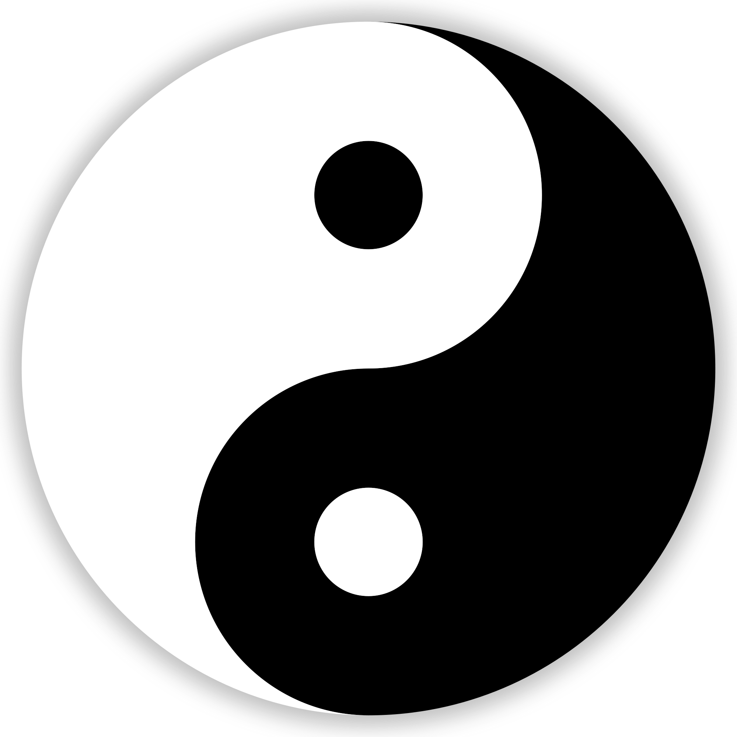

- Look at this image of a yin yang symbol. How does it visually demonstrate the concept of balance?

