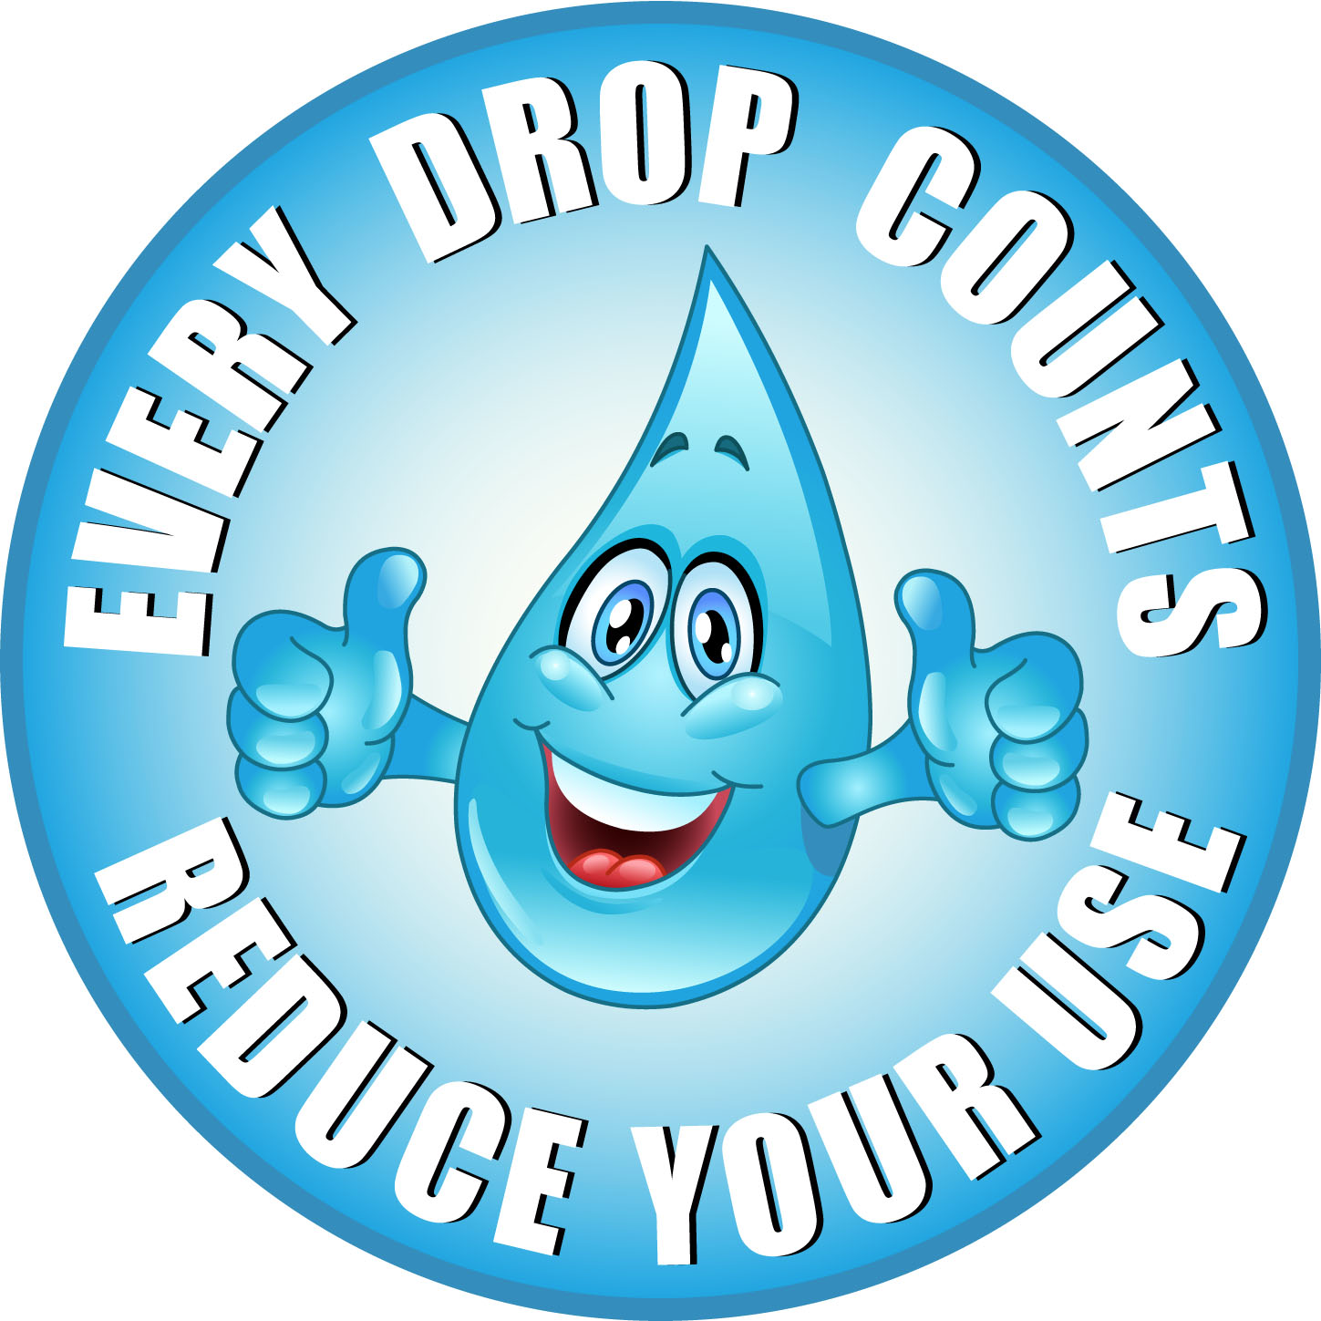
Humanities CAT Modified

- Watch this video https://www.youtube.com/watch?v=l67HwLegDLE

Create a mind map on ways we use water around the house and around Australia. You can create this on Popplet, Mindmap or use on the mind map sheets at the front of the year 7 Learning Common.

- Have a look at the graph below on water usage in Australian.
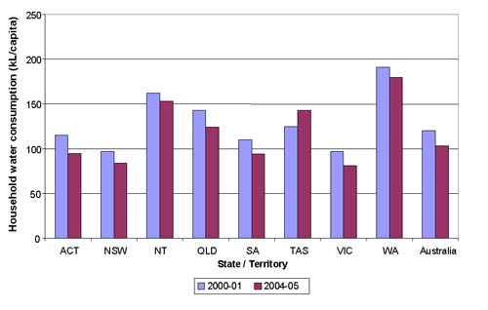

Answer the following questions in your humanities book.

- Who has the highest water usage and how much do they use in 2004-2005? Give three reasons why they would use more water than other states

- Who has the lowest water usage in 2004-2005 and how much do they use? Give three reasons why they use less water than other states.

- Why do you think water usage has decreased in most states? Give 3 reasons.

3. Watch the following videos about desalination plants

https://www.youtube.com/watch?v=bggjUPSsq80

https://www.youtube.com/watch?v=aysj7696b0A

https://www.youtube.com/watch?v=oaQCiwzjnCM

Use any app on your i-pad to answer the following questions. Be as creative as you like.

- What does a desalination plant do?

- Why do you think it is important to have a desalination plant?

- List 10 ways of saving water around the household or Australia. Draw a picture for each way.

