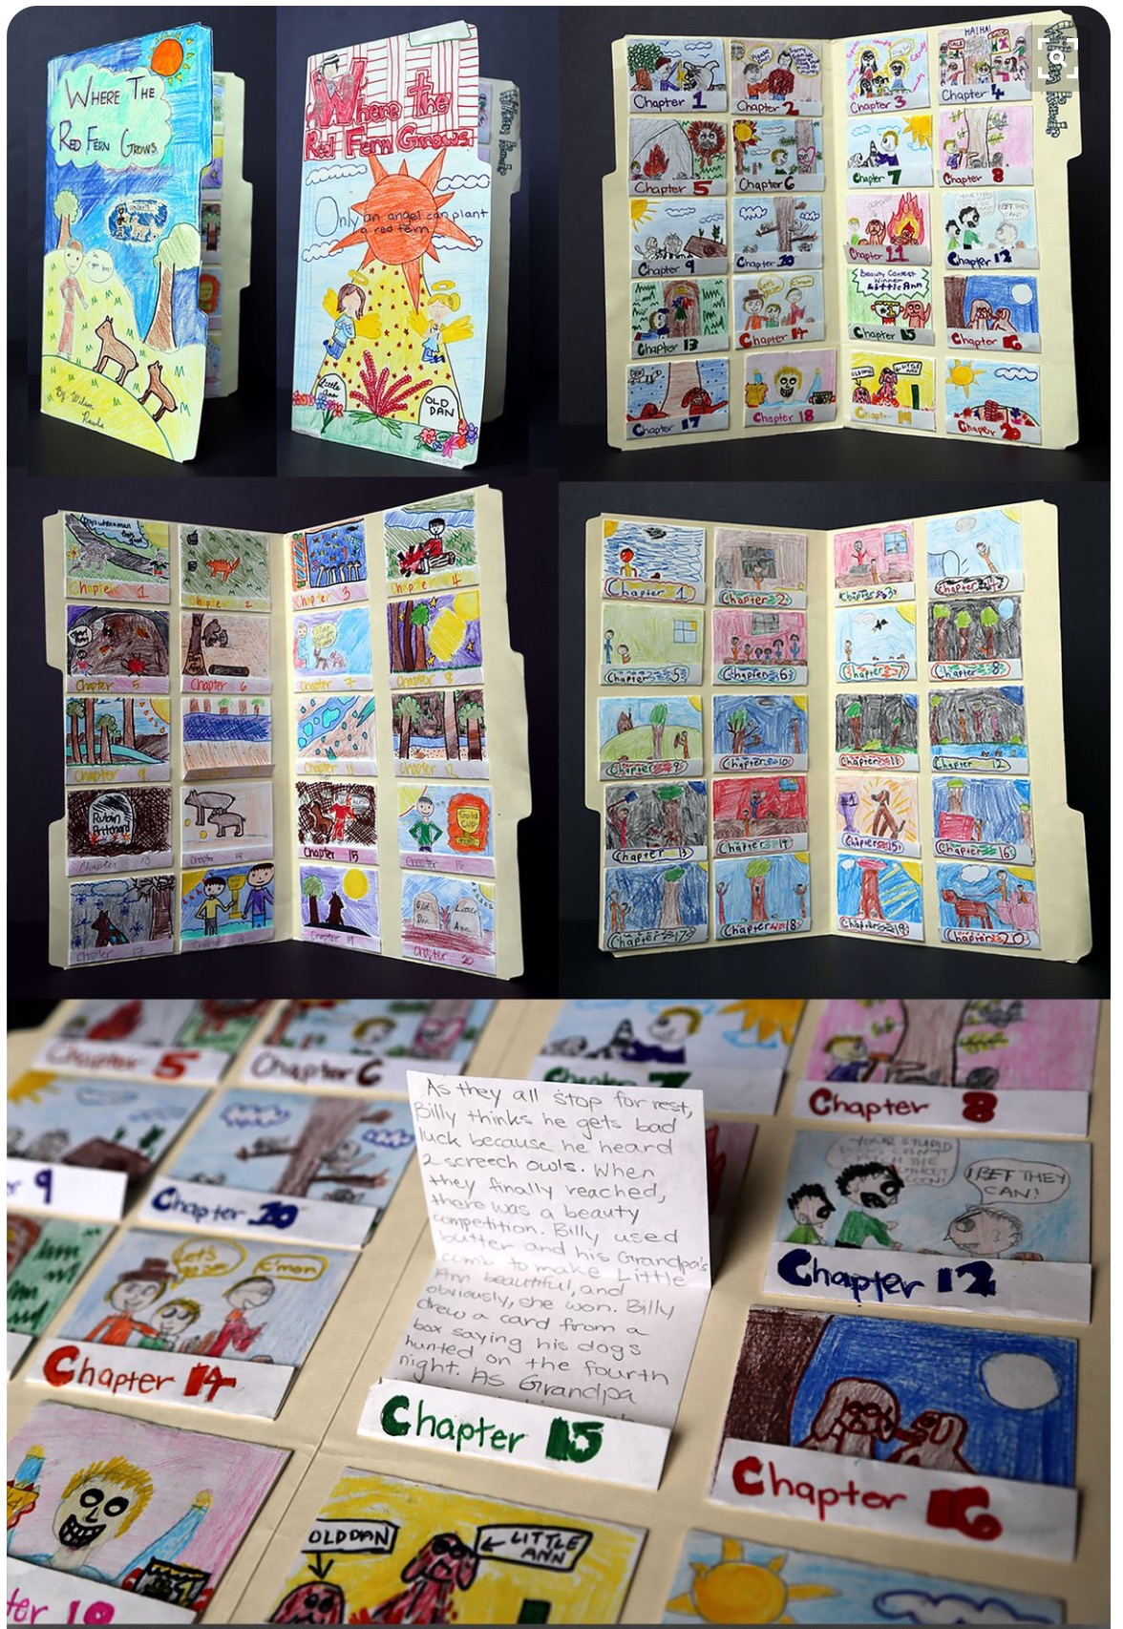

‘Little Brother’ Picture Summary

**Create a visual chapter summary of ‘Little Brother’ using a manila folder, white paper and colour pencils.**   
  
You will need to include a flap for each chapter, draw an image to represent the chapter on the front and write your summary on the inside.   
  
See the pictures for more guidance.