Year 7 Science Unit 2 – Tutorial 6

Investigating gravity using a robocopter
A robocopter is a paper construction that spins as it falls when it is dropped from a height. Your task is to make a robocopter and then investigate how changing one variable or factor affects the time that it takes to fall. The design of a robocopter is shown in Figure 1.
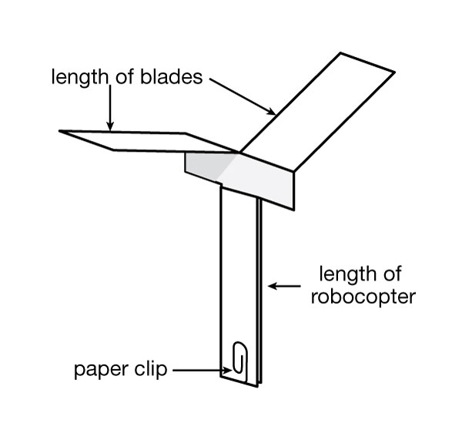
Figure 1. A completed robocopter

To build your robocopter, cut a copy of the template shown in Figure 2 onto a piece of paper or cardboard. Cut along solid lines and fold along dotted lines, as shown by the arrow. Place a paper clip at the base as shown in Figure 1 and you are ready for a spin. Full instructions are found in Figure 3.

Once you have built your robocopter, you need to drop it from a set height and time how long it takes to fall to the ground..

Each group should make at least two different designs!

What you could change in your designs:
- changing the length of its blades
- adding more paper clips to its base
- making different-sized robocopters
- making robocopters from different thicknesses of paper or cardboard.

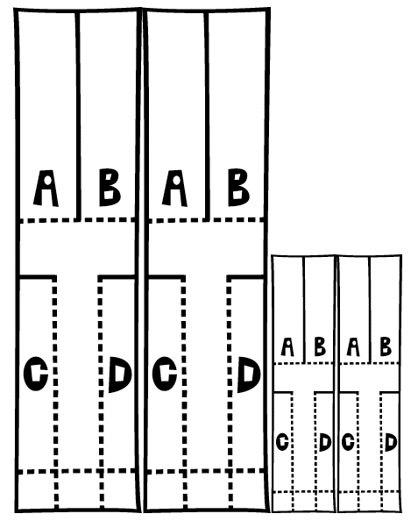

Figure 2: Robocopter design template. Create your robocopter by drawing this lines on a piece of paper and following the instructions on the next page.
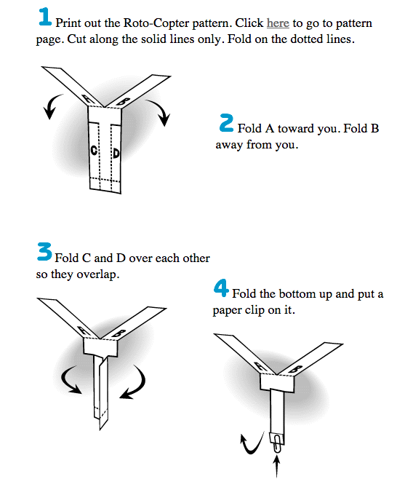
Figure 3: How to build your robocopter once you have used the template.

Your Task by the end of the lesson:
- Write an Aim for your investigation

- List the Materials needed and the Methods you followed.

- Record your Results in a table. You should drop your robocopter from a set height and time how long it takes to hit the ground.

- Make sure you write about what you observed in your Discussion.

- Any problems that you found in a Conclusion that summarises your findings.

Your experimental report: Use the headings on the next page to create your report.

Title:

Aim:

Materials:

Methods:
1.

Results:
Explain your design (e.g. Size, weight) | Height Dropped From  (Should always be the same) | Time taken to reach the ground

Discussion:
What was the difference in the time it took to fall to the ground between your different designs?

What forces caused the difference in drop times? Think about what changes you made to your design.

Conclusion:
What went well in this experiment?

