Unit 1 - Chemical Sciences Task Card Activity
There are different states of matter all around you. Below you will see an image of the beach.
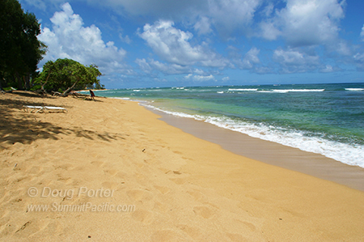

Your task:
You need to classify (name) the different things you see in the image above as a liquid, gas or solid. For each thing you name, you need to explain why you called it a liquid, solid or a gas? What helped you make that decision?

A liquid I can see is:

Why?

A solid I can see is:

Why?

A gas I can see is:

Why?

