S2: Friction Work Sheet

Question 1: Complete the sentences by using the words below.

force slow still touching

Friction is the ______________between two ______________ objects. It can _____________ things down or make things stand ________________.

Question 2: Look closely at each picture and answer the question in detail.

- Which boy will have more friction under his feet? Why?
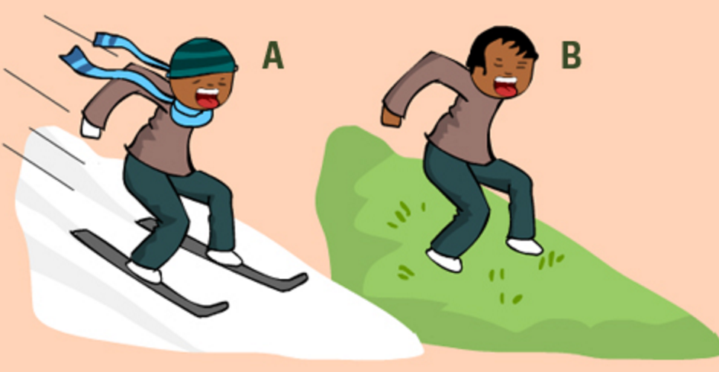

- Which wheel will have more friction on a road and why?
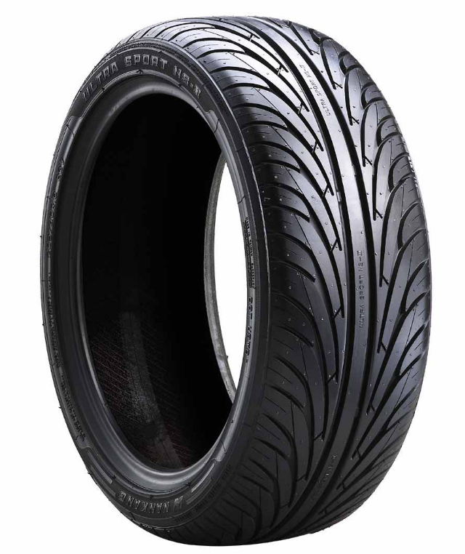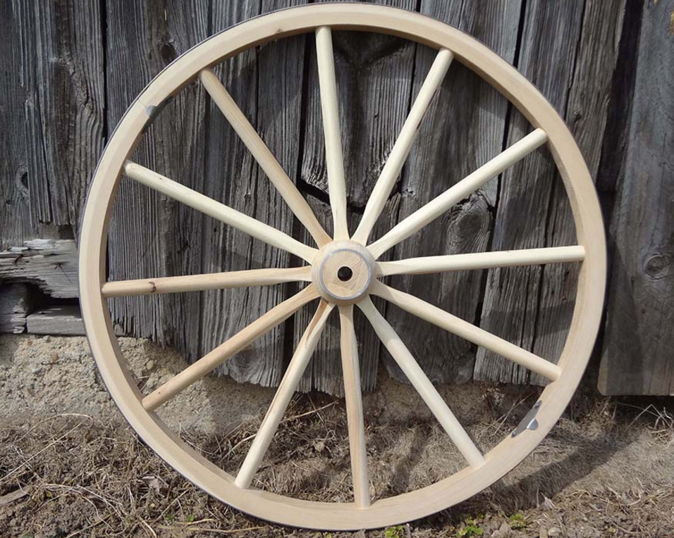

- What is the purpose of a rubber bath mat? Use the word Friction in your answer.
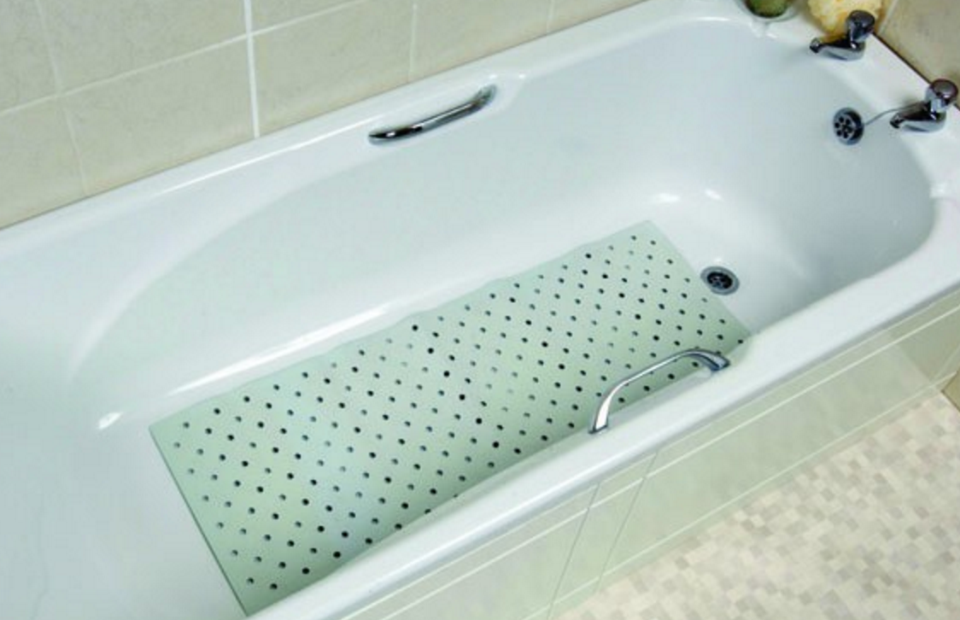

- Below is a picture of bicycle brakes. How do these stop the bike? Use the word friction in your answer.

