Skateboards
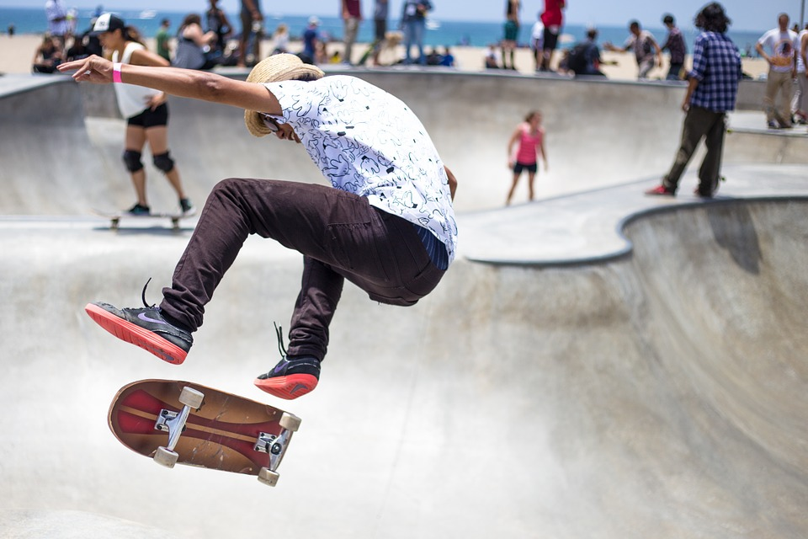

Background
A skateboard is a small piece of wood in the shape of a surfboard with four wheels attached to it. A single person rides the skateboard, guiding the movement with his feet. While some use skateboards as transportation over short distances, most are used to perform stunts.
Skateboards consist of three parts: the deck (the actual board), the truck (a component usually made of metal that holds the wheels to the deck), and the wheels. The average skateboard deck is about 32 in (81.3 cm) long, 8 in (20.3 cm) wide, and is a little less than 0.5 in (1.3 cm) thick. The deck has a defined nose and tail with a concave in the middle. Skateboard wheels are usually made of polyurethane and range in width from about 1.3-1.5 in (3.3-3.8 cm). While nearly all skateboards have similar shapes and characteristics, their dimensions vary slightly based on use. There are skateboards built for speed, slalom, and freestyle.
Since skateboards first came into widespread use in the 1960s, their popularity has come in waves. Newfound interest is usually related to technical innovation, though a core constituency of skateboard enthusiasts has always remained.

History
Though there is unconfirmed evidence that a skateboard-like apparatus existed as early as 1904, the more commonly accepted predecessor to the skateboard was created in the 1930s. In Southern California, a skate-scooter was made out of fruit crates with wheels attached to the bottom. This evolved into an early skateboard that was made out of 2x4 ft (61x121.9 cm) piece of wood and four metal wheels taken from a scooter or roller skates. This version of the skateboard featured rigid axles which cut down on the board's maneuverability.
Recognizable skateboards were first manufactured in the late 1950s. These were still made of wood and a few were decorated with decals and artwork. Skateboards became especially popular among surfing enthusiasts, primarily in California. Surfers practiced on skateboards when the ocean was to rough, and they soon became known as "sidewalk surfers." One of the first competitions was held for skateboarders in 1965. While skateboards were popular through most of the 1960s, riders were not respected and the activity was banned in some cities. The first wave of skateboard popularity was over by 1967.
Five years later, in 1973, there was a renewed interest in skateboards when wheels made of polyurethane were introduced. These early polyurethane wheels were composites of sand-like material that was formed into a wheel with an adhesive binder under extreme pressure. With the advent of polyurethane wheels, boards became easier to control and more stunts were possible.
Also in the 1970s, skateparks were introduced. Skateparks were specially designed places that catered to skateboarders. They had obstacle courses, pools (empty bowls, usually below ground level like an empty pool), and pipes (large, circular type) to challenge skateboard riders. With skateparks also came more competition, recognition, and sponsorship. Skateboarders sometimes decorated the bottom of their boards with logos of their sponsors. By the end of the 1970s, skateboarding again became controversial after it became identified antisocial behavior. Due to the amount and severity of the injuries, skateparks closed in fear of lawsuits and the sport returned underground.
When popular interest in skateboarding briefly re-emerged in the mid-1980s, it was not due to any particular technical innovation, though skateboard manufacturers were always experimenting with different materials in the production of decks. Instead, skateboarding videos featuring skateboarders performing extremely difficult and dangerous stunts using ramps, stairs, and even handrails generated new interest in the sport. At the same time skateboard art had also emerged. The bottom of skateboard decks were now elaborately decorated with logos and other designs. Continued resistance to skateboarders led to another down-turn in popularity at the end of the 1980s, though not as severe as previous years.
By the middle of the 1990s, skateboarding again became popular mainly due to high-profile exposure like ESPN and MTV's X-Games competitions. These televised events of "extreme sports" showed the best of many kinds of skateboarding. Skateboarding was regarded as the first extreme sport. Though skateboarding was still banned or regulated in many communities, such exposure gave the sport an air of legitimacy. It is not as dangerous a sport as many think. In 1997 there were 8.2 million skateboards and around 48,186 reported injuries, 0.006% of which resulted in hospitalization. Compared to a more commonly accepted sport like basketball—which had 4.5 million participants in 1997 and 644,921 reported injuries (0.124% resulting in hospitalization)—the fear seems misplaced.
Skateboard art also continued to evolve. Art was based on street trends and whatever was hot at the moment: comics, bands, logos, and original art. In the mid-1990s, deck manufacturers would introduce an average of six board designs per month, making only 1,000 of each. While skateboard manufacturers experimented with different thicknesses of veneers that made up decks, little changed in the actual manufacture of skateboards at the beginning of the twenty-first century.

