Tutorial 3 – Water Carrying Experiment

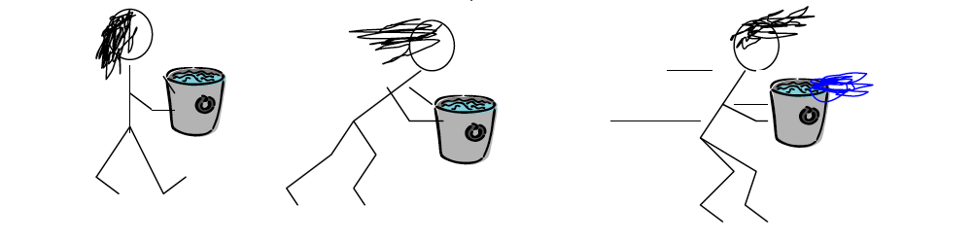

Aim: To test the effect of forces on a container of water.

Hypothesis: What do you think will happen to the water?

Materials:
- Cones or markers to create obstacle course
- Plastic Beaker
- Water
- iPad

Methods:
- In groups of three, design an obstacle course with at least three turns, two changes of speed, and a jump section. Give each of these sections a number.

- One person fills a container/beaker with water 1cm below the rim.

- Observe the obstacle course ahead of you and predict what will happen to the water at each point.

- . Draw a diagram to show what forces you think will act on the water.

- Run the course to test your predictions, once person carries the water, one records on an iPad and one gives directions through the course.

Results:
- What happened at different parts of the course?
- State the section and what happened.

Discussion:
- How does the activity you just did relate to forces?

- What forces do you think were in action?

- What evidence do you have that forces were in action?

- When do you think they were balanced? Why?

- When do you think they were unbalanced? Why?

Conclusion:
What went well in the experiment?
What could have gone better.

