Workshop 5: Writing a Laboratory Report

After completing the experiment, in your group write up your own version of the experiment use the experimental design headings:
Title, Aim, Hypothesis, Materials, Methods, Results, Discussion Questions, Conclusion

This investigation is really a test of your powers of observation. As you watch the sugar cube dissolve, write down everything that happens. Use short sentences to record everything in your Results section.

Practical: Dissolving Sugar Crystals
TITLE: What happens when sugar is dissolved into water?

MATERIALS:
250 ml beaker (2)
Stirring rod
Thermometer
Sugar cubes (2)

METHOD:
- Fill a beaker with 200 ml of cold water from the tap. Weigh the beaker and sugar cube. Measure the temperature of the water in the beaker.
- Drop in a sugar cube. Watch it carefully. Write down everything that happens, everything that you notice.
- After about five minutes, when everything settles down, finish off the dissolving by stirring with the glass rod.
- Finally weigh the beaker which now contains the dissolved sugar cube.
- Repeat steps 1-4 but this time fill the beaker with 200 ml of warm water from the tap.

RESULTS: Record the weight of the water and beaker, and the sugar cube. Also record the temperature of the water before each experiment.

DISCUSSION QUESTIONS:
- Which observations suggest to you that the sugar is no longer in the water after dissolving?
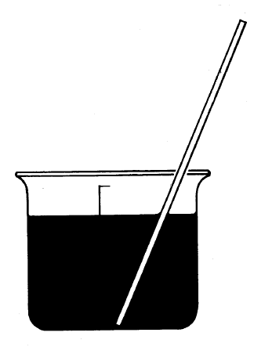
- Which observations suggest to you that the sugar is somewhere in the water after dissolving?
- What evidence suggests that the sugar is somewhere in the water after dissolving?
- What is the effect of temperature on the dissolving sugar cube?
- Can you suggest some other simple experiments to find out what has happened to the sugar?

