Year 7 Science – Fish Dissection

Part One: Introduction to your fish

- Where do you think your fish spends most of its time in the water?
e.g. Swimming fast, hiding on the bottom, swimming close to the surface.

- What do you think your fish eats? Look at the shape of the mouth, teeth and jaw size to help.

- How do think your fish finds its prey?

- What does the shape of the body suggest about the fish?

- What can you tell about how the fish moves from its fins?

- Is your fish a fast swimmer, or a slow mover? Why?

- Go to this website to try and identify your fish.

Part Two: External features of your fish

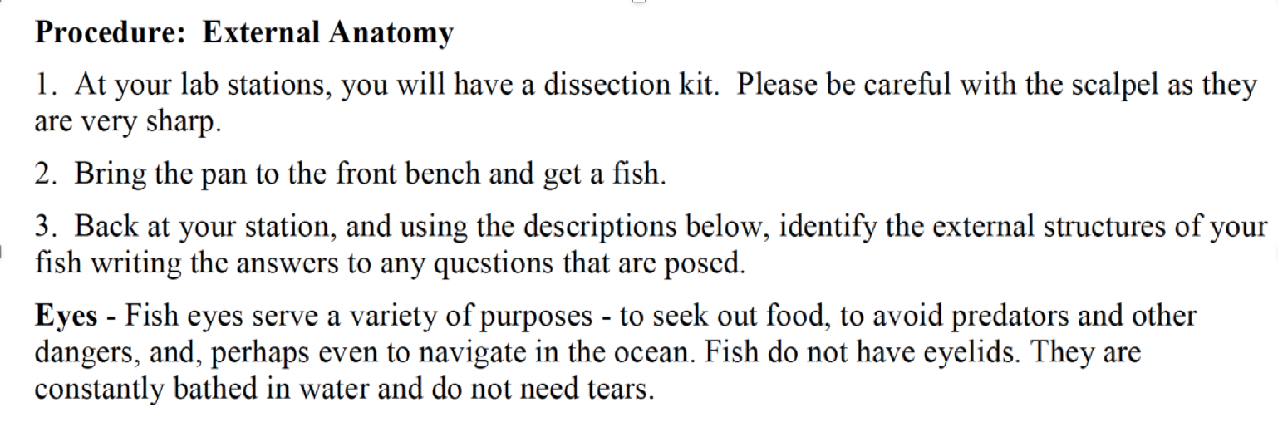

5. Using your finger, gently move the eye in its socket. Is there an eyelid present? If there is, what does this tell you?

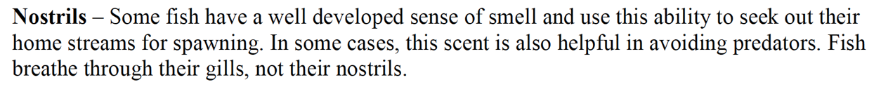
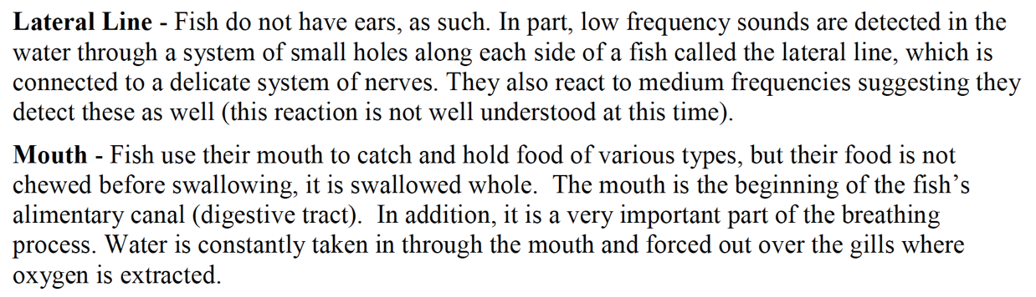

6. Feel inside the mouth for teeth. Open and close the mouth. Describe how the upper and lower jaw moves when you do this.

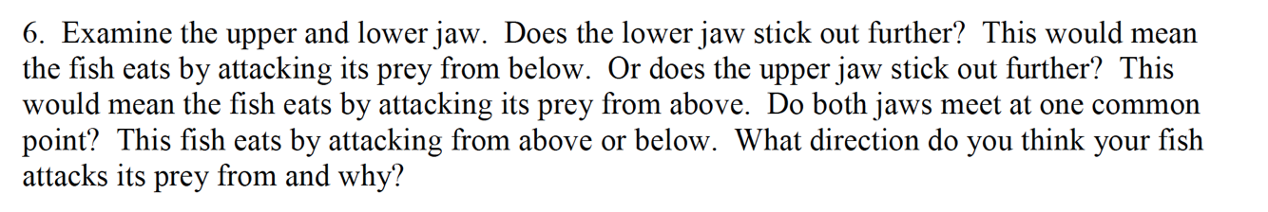

7. From looking at your fish’s jaw, how do you think it attacks its prey?

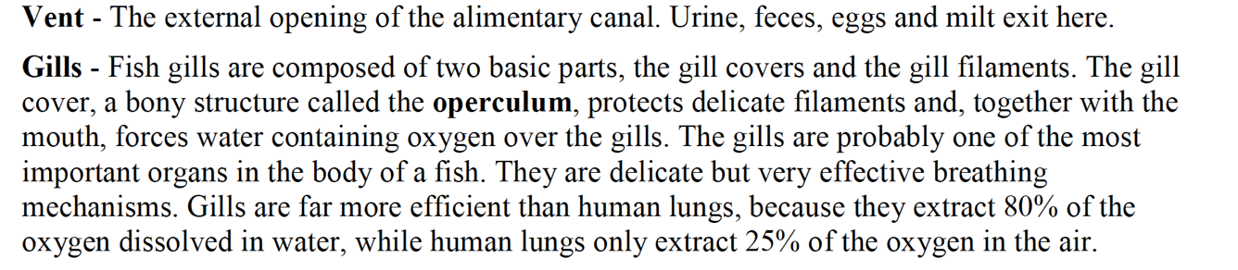

8. Grasp the operculum to feel the bony structure. What is the benefit of having this hard structure over the gills?

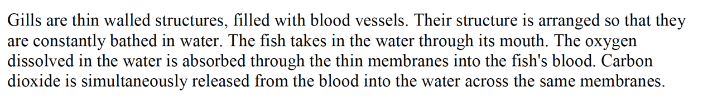
9. Open the operculum and look inside at the gills. Describe them, using at least three different adjectives (describing words)

10. Label the fish diagram below with the correct names for each of the fins. Also label the dorsal, anterior, posterior and ventral side of the fish.

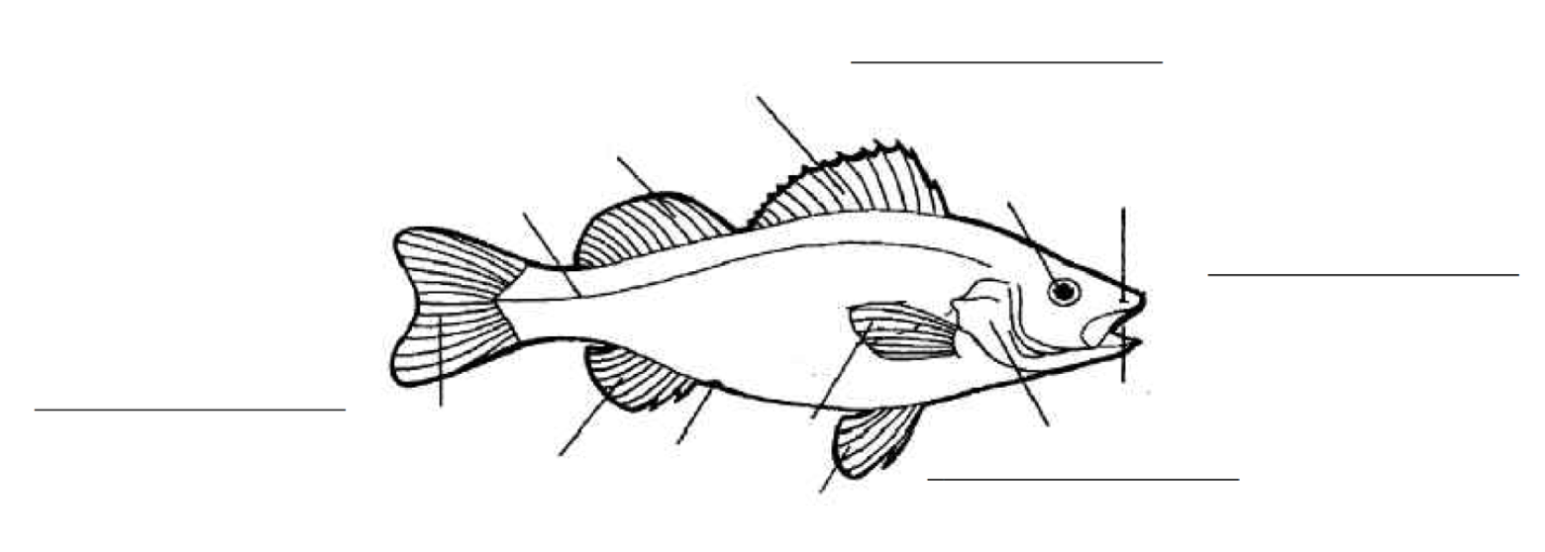

11. Fish bodies are protected by scales. Scales have a layer of mucous (slime) that helps protect the fish from disease organisms and helps it slide through the water more easily. Carefully remove one of the scales and look closely at it.

Part Three: Internal features of your fish.

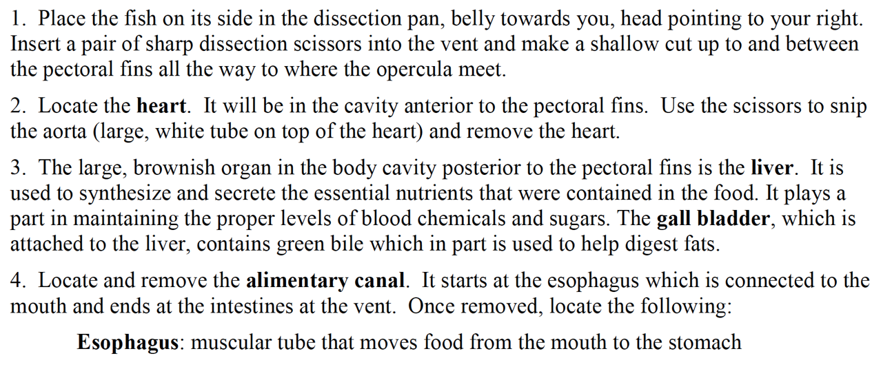

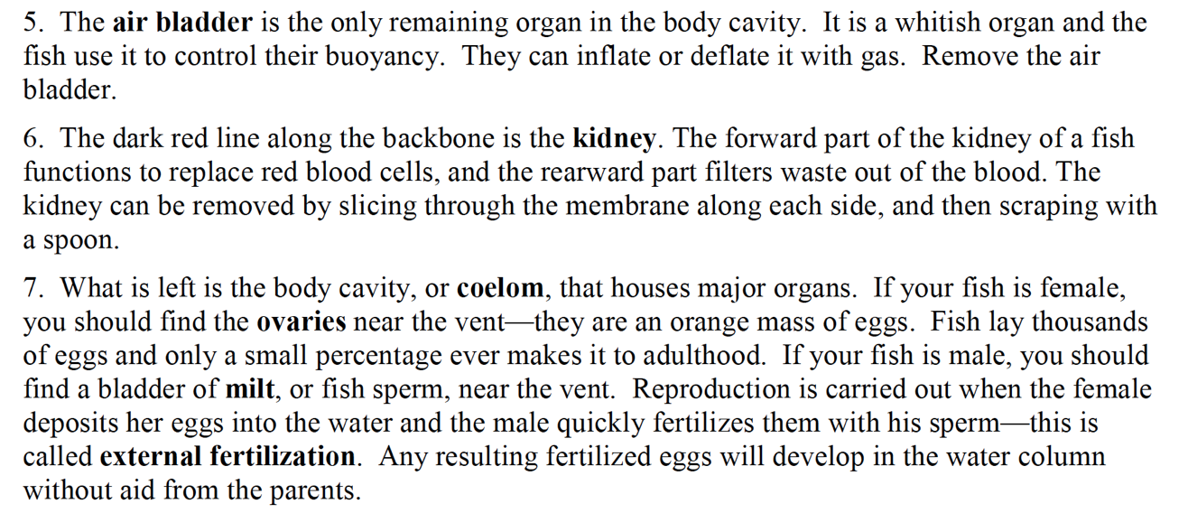

12. Is your fish male or female?

