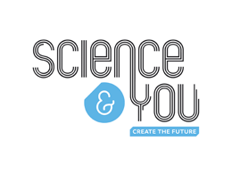

Step 1: Write 3 things you enjoy about science:

1.

2.

Step 2: Write 3 things you find challenging about science:

1.

2.

3.

Step 3: Draw a picture about what science means to you:

Step 4: Write a short paragraph to summarise what you have found in steps 1-3

